DRAFT Model Standing Orders
June 2014

- Antibiotic Prophylaxis Against Bacillus anthracis (Anthrax)

- Antibiotic Prophylaxis Against Yersinia pestis (Plague)

- Antibiotic Prophylaxis Against Francisella tularensis (Tularemia)

Standing orders must be consistent with the provisions of the Emergency Use Authorizations (EUAs) that have been issued for the current event.

Standing Orders for a Mass Antibiotic Prophylaxis Dispensing Site
Following a Bioterrorism Attack With Bacillus anthracis (Anthrax)
Date and time this order was implemented:
_____________

_____________

I direct nurses employed by, or serving as volunteers for, the
___________________________________________________ (name of Agency/Organization) to
dispense medications to individuals presenting for prophylactic treatment to Bacillus anthracis.

All medications must be dispensed in accordance with the following prophylactic treatment guidelines and within the restrictions of the guidelines of the Strategic National Stockpile program.

Recommendations for Oral Antimicrobial Post-Exposure Prophylaxis (PEP) for Bacillus anthracis

Nonpregnant Adults: Oral Antimicrobial Postexposure Prophylaxis for Bacillus anthracis*

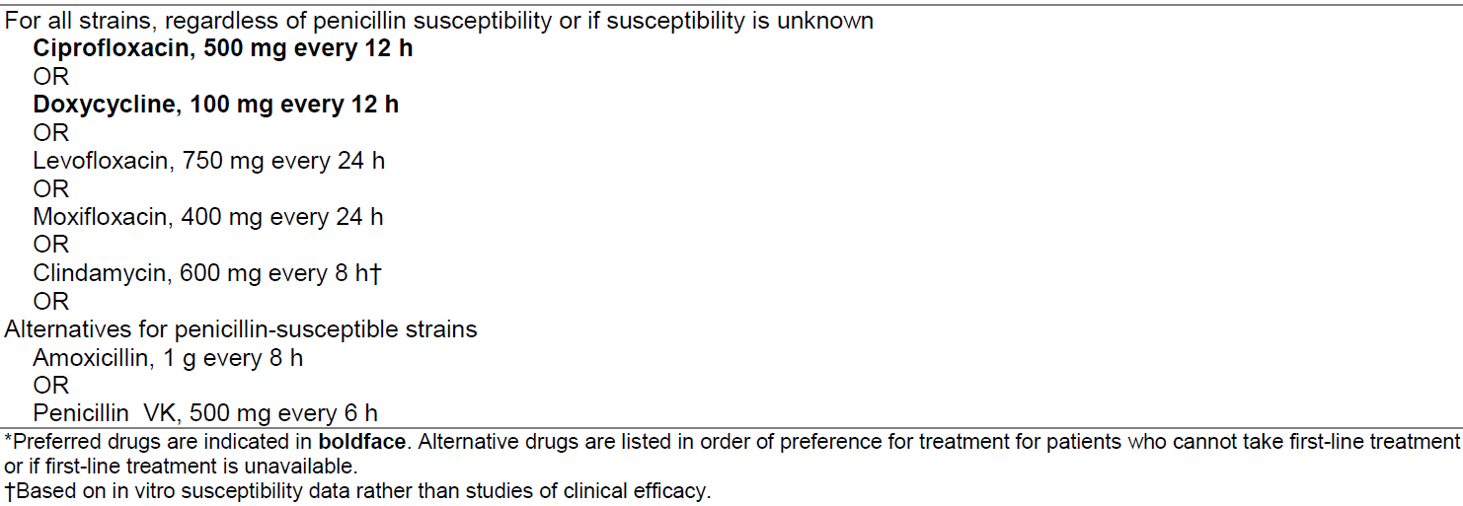

Everyone exposed to aerosolized B. anthracis spores should receive a full 60 days of PEP antimicrobial drugs, whether they are unvaccinated, partially vaccinated, or fully vaccinated.

Ciprofloxacin, levofloxacin, and doxycycline are FDA-approved for the antimicrobial drug portion of PEP for inhalation anthrax in adults ≥18 years of age. Oral ciprofloxacin and doxycycline are recommended as first-line antimicrobial drugs for PEP. Alternative antimicrobial drugs that might be used for PEP if first-line agents are not tolerated or are unavailable include levofloxacin and moxifloxacin; amoxicillin and penicillin VK if the isolate is penicillin susceptible; and clindamycin.

Source: Hendricks KA, et al. Centers for Disease Control and Prevention expert panel meetings on prevention and treatment of anthrax in adults. Emerg Infect Dis [Internet]. 2014 February. http://wwwnc.cdc.gov/eid/article/20/2/13-0687_article.htm
_____________________________________________________________________________________

Pregnant and Postpartum Women: Oral Antimicrobial Post-Exposure Prophylaxis for Bacillus anthracis*

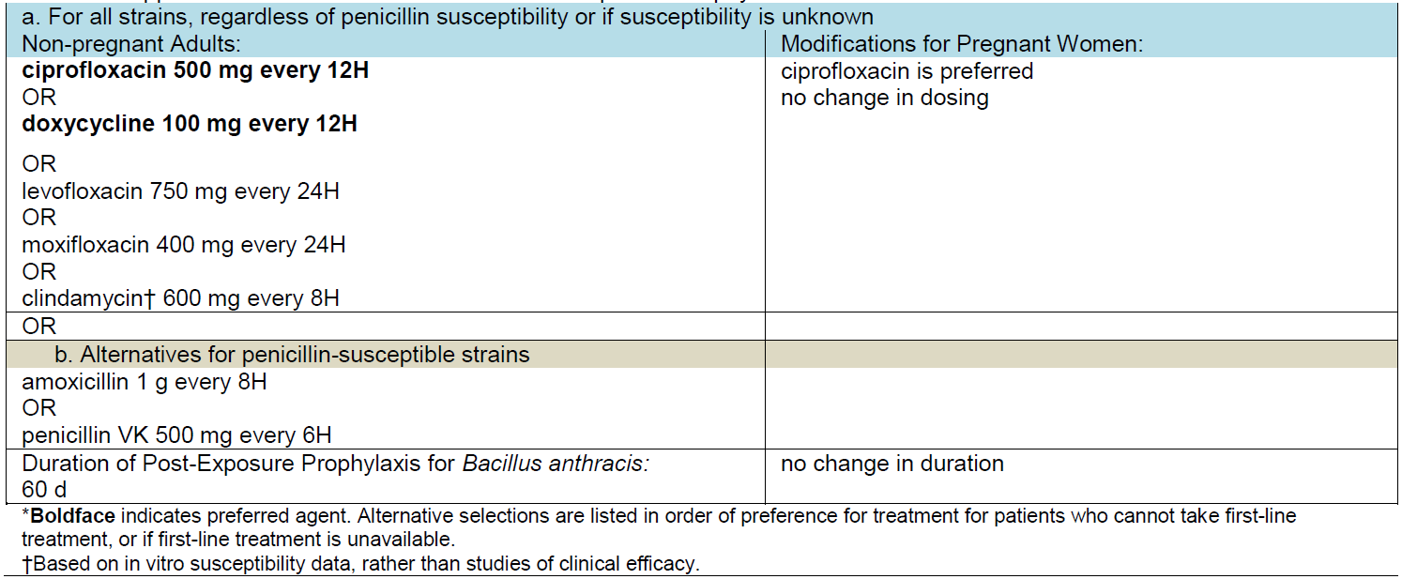

Antimicrobial drug PEP should be administered for 60 days, whether recipients are unvaccinated, partially vaccinated, or fully vaccinated.

Source: Meaney-Delman D, et al. Workgroup on Anthrax in Pregnant and Postpartum Women. Special considerations for treatment of anthrax in pregnant and postpartum women. Emerg Infect Dis [Internet]. 2014 February. http://wwwnc.cdc.gov/eid/article/20/2/13-0611_article.htm

Infants, Children, Adolescents, and Young Adults up to the Age of 21: Antimicrobial Post-Exposure Prophylaxis for Bacillus anthracis (for Children 1 Month of Age and Older)
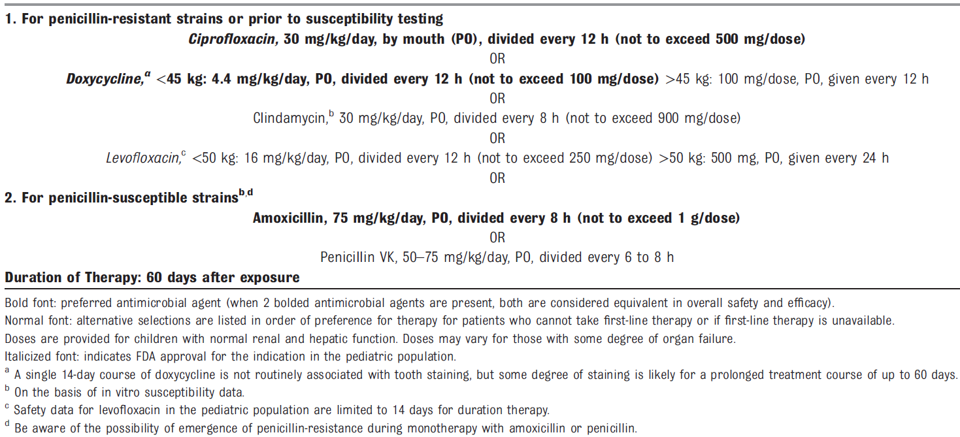

All children believed to be exposed to aerosolized B. anthracis spores should receive at least 60 days of antimicrobial prophylaxis.

A limited supply of oral suspension formulations of recommended PEP antimicrobial agents will be available, and distribution strategies will be determined by public health authorities. If oral suspensions are not readily available, doxycycline tablets will be provided with clear directions, as recommended by the US Food and Drug Administration (FDA), on how the tablets can be crushed and added to a food or liquid to create a formulation that is more palatable and designed to improve adherence for those who are unable to swallow a tablet (see http://www.phe.gov/Preparedness/legal/pahpa/Pages/pahpra.aspx)

Source: Bradley JS, et al. Pediatric anthrax clinical management. Pediatrics 2014;133(5):e1411-e1436 http://pediatrics.aappublications.org/content/133/5/e1411.full

Individuals presenting to a dispensing site to receive prophylactic medication will be asked to complete a medical assessment questionnaire. Medication will be dispensed based on the answers provided, using a protocol approved for use at the dispensing site. This order will terminate _______________
Date

_______________________________________ _____________________
Physician Date of Signature

Standing Orders for a Mass Antibiotic Prophylaxis Dispensing Site
Following a Bioterrorism Attack With Yersinia pestis (Plague)
Date and time this order was implemented:
_____________

_____________

I direct nurses employed by, or serving as volunteers for, the
___________________________________________________ (name of Agency/Organization)
to dispense medications to individuals presenting for prophylactic treatment to Yersinia pestis.

All medications must be dispensed in accordance with the following prophylactic treatment guidelines and within the restrictions of the guidelines of the Strategic National Stockpile program.

Recommendations for Oral Antimicrobial Post-Exposure Prophylaxis (PEP) for Yersinia pestis

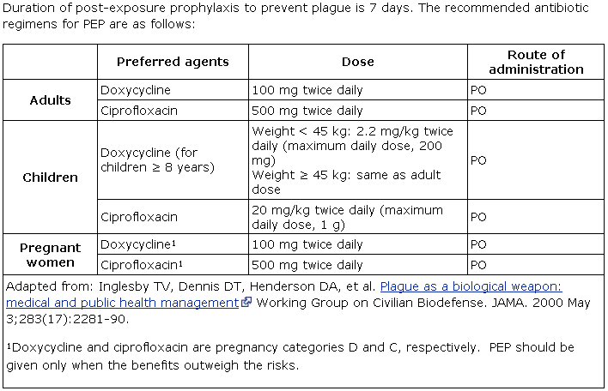

Source: CDC. Resources for Clinicians: Post-exposure prophylaxis (PEP), April 25, 2014. (http://www.cdc.gov/plague/healthcare/clinicians.html)

Individuals presenting to a dispensing site to receive prophylactic medication will be asked to complete a medical assessment questionnaire. Medication will be dispensed based on the answers provided, using a protocol approved for use at the dispensing site. This order will terminate _____________________
Date

_______________________________________ _____________________
Physician Date of Signature

Standing Orders for a Mass Antibiotic Prophylaxis Dispensing Site
Following a Bioterrorism Attack With Francisella tularensis (Tularemia)
Date and time this order was implemented:
_____________

_____________

I direct nurses employed by, or serving as volunteers for, the ___________________________________________________ (name of Agency/Organization) to
dispense medications to individuals presenting for prophylactic treatment to Francisella tularensis.

All medications must be dispensed in accordance with the following prophylactic treatment guidelines and within the restrictions of the guidelines of the Strategic National Stockpile program.

Recommendations for Oral Antimicrobial Post-Exposure Prophylaxis (PEP) for Francisella tularensis

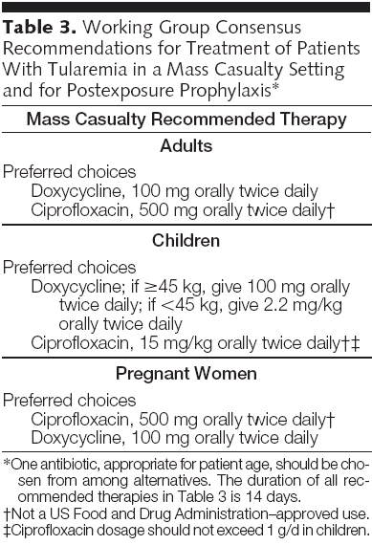

Reference: Dennis DT, et al. Tularemia as a Biological Weapon: Medical and Public Health Management. JAMA 2001; 285:2763-73-90.

Individuals presenting to a dispensing site to receive prophylactic medication will be asked to complete a medical assessment questionnaire. Medication will be dispensed based on the answers provided, using a protocol approved for use at the dispensing site. This order will terminate _____________________
Date

_______________________________________ _____________________
Physician Date of Signature

