Missouri Board of Nursing Home Administrators
920 Wildwood Drive/P.O. Box 570
Jefferson City, MO 65102
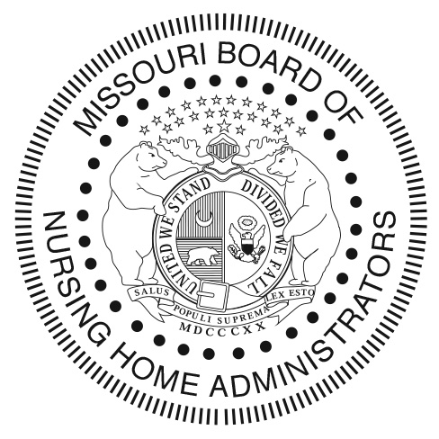
Phone: (573) 751-3511 Fax: (573) 526-4314
Email: bnha@health.mo.gov
Website: www.health.mo.gov/bnha

MISSOURI PRECEPTOR APPLICATION

Name: _______________________________________________________________________________

License Number: _____________ Date Issued: _____________ Expiration Date: ____________

Employment Information:

Facility Name: ____________________________________________ Title: _____________________

Address: _____________________________________________________________________________

City: __________________________ State: _________________ Zip: ______________________

Phone Number: ______________________ Email Address: __________________________

Preferred Method of Contact (Email/Phone): ________________________________________________

Length of Employment: ______________________ Current Facility (Y/N): _____________________

*If you have not been with this facility for at least one (1) year please provide an additional list of facilities that includes the above information to prove that you have been employed as an administrator for at least a total of one (1) year within the past three (3) years immediately preceding this application*

Have you successfully completed the Board approved Preceptor Training Program? ___ Yes ___No
(If yes, please attach a copy of the certificate of completion)

Agreement:

My signature below certifies that I have read and fully understand all of the requirements and rules as stated both on the Board’s website and described in 19 CSR 73-2.031. My signature below also indicates that I completely understand my responsibility and the importance of the role of a Certified Preceptor.

Signature: _____________________________________________ Date: _____________________

